# Azure App services in Xamarin

1. Go to <https://ms.portal.azure.com>
2. Go to New > Web+Mobile > Mobile App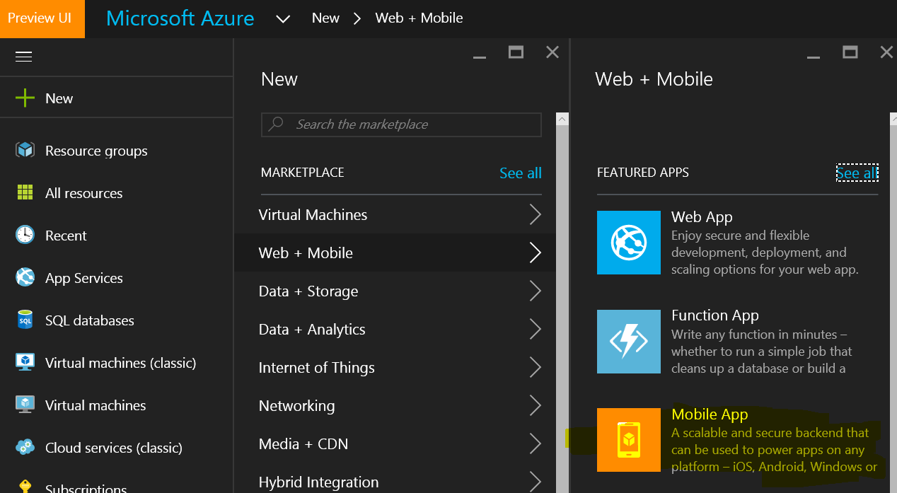
3. Give a **AppName** and a **ResourceName**

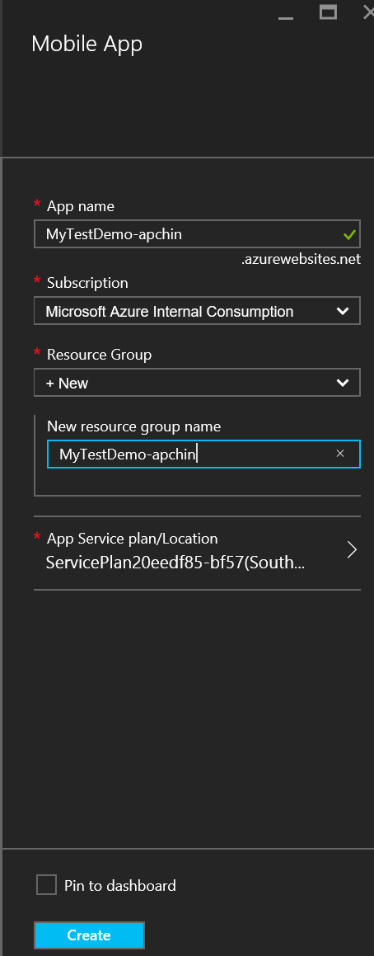

1. Go to your Mobile app Created > Settings > Quick Start > Xamarin Forms > **Connect a database.**
2. Create a table API – Backend Language choose Node.js > **Create ToDoItem Table**  
     
   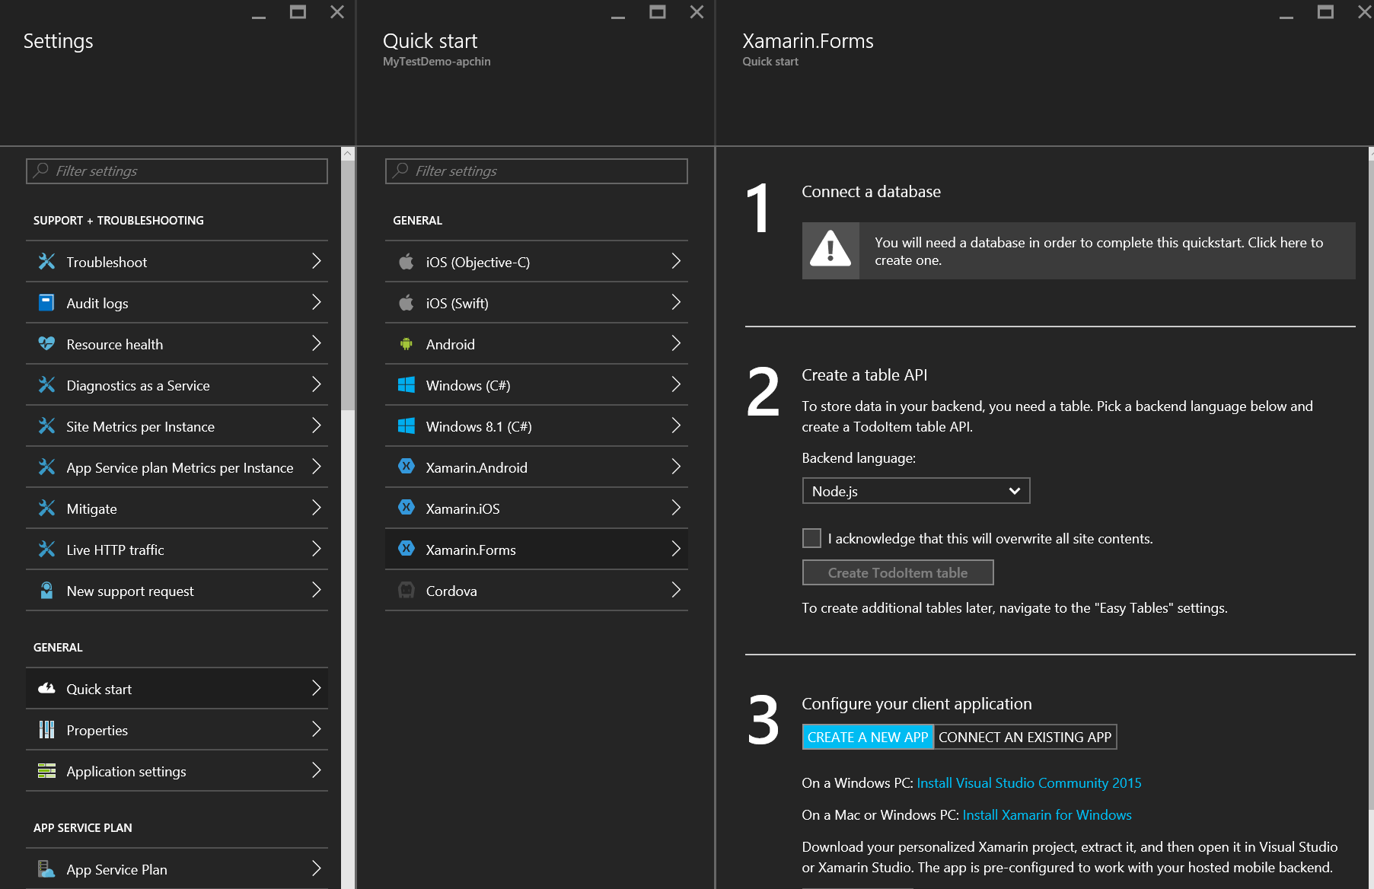

# C# Code Snippets

**Class ToDoItem**

==============================================================

public class TodoItem

{

string id;

string name;

[JsonProperty(PropertyName = "id")]

public string Id

{

get { return id; }

set { id = value; }

}

[JsonProperty(PropertyName = "text")]

public string Name

{

get { return name; }

set { name = value;

}

}

[Version]

public string Version { get; set; }

}

Saving items to Azure

**Declare the below in the App.cs**

Microsoft.WindowsAzure.MobileServices.IMobileServiceTable<TodoItem> todoTable;

string ApplicationURL = @"https://<Your MobileApp Name>.azurewebsites.net";

**Initialize the below in the Constructor**

MobileServiceClient client = new MobileServiceClient(

ApplicationURL);

todoTable = client.GetTable<TodoItem>();

**Add to Azure button click event**

private async void AddToAzure_Clicked(object sender, EventArgs e)

{

var todo = new TodoItem { Name = result.Text + "Something else"};

await AddItem(todo);

}

private async Task AddItem(TodoItem todo)

{

await SaveTaskAsync(todo);

}

public async Task SaveTaskAsync(TodoItem item)

{

if (item.Id == null)

{

await todoTable.InsertAsync(item);

}

else

{

await todoTable.UpdateAsync(item);

}

}

# Adding Nuget Packages

1. Right Click on the portable project > Manage NuGet Packages.
2. You need to install the below packages –

**WindowsAzure.MobileServices**

**Newtonsoft.Json**

1. Repeat Step 2 for Xamarin.UWP project as well.

# Retrieve Items from Azure table

Microsoft.WindowsAzure.MobileServices.IMobileServiceTable<TodoItem> todoTable;

public async void getitems()

{

string ApplicationURL = @"https://apchin-todo.azurewebsites.net";

MobileServiceClient client = new MobileServiceClient(

ApplicationURL);

todoTable = client.GetTable<TodoItem>();

ListViewBox.ItemsSource = await GetTodoItemsAsync();

}

public async Task<ObservableCollection<TodoItem>> GetTodoItemsAsync(bool syncItems = false)

{

try

{

IEnumerable<TodoItem> items = await todoTable

.ToEnumerableAsync();

return new ObservableCollection<TodoItem>(items);

}

catch (MobileServiceInvalidOperationException msioe)

{

Debug.WriteLine(@"Invalid sync operation: {0}", msioe.Message);

}

catch (Exception e)

{

Debug.WriteLine(@"Sync error: {0}", e.Message);

}

return null;

}